  - Remembrance Day
  - November 11th
Lest We Forget

remember to take a moment of silence on november 11th |  | we are called to love and be loved

Scholastic Book Fair!
The Scholastic Book Fair arrives on Monday, November 6th for the week. Classes will visit during the school day, starting on Tuesday. Students will be offered ample time to view the books, make up wish lists and to purchase books. The Fair will also be open during Parent/Teacher interviews on Wednesday, November 8th and Thursday, November 9th evenings.
This is a great opportunity for parents, guardians and grandparents to pick up Christmas stocking stuffers and all are invited to visit the fair during the school day, or during the evening hours. Please sign in at the office if visiting during the day.
Fair Hours
Monday and Tuesday
8:15 – 2:35
Wednesday and Thursday
8:15 am - 8:00 pm
Friday
8:15 - 11:35 am

Cereal and Snack Drive
November 7th till November 10th St. Michael’s Food for Learning program will be hosting the Fourth Annual Cereal and Snack drive. We are in need of donations to help support our daily Breakfast Club and Snack program. Here is an approved list of cereals and snacks that can be provided. Students can bring the items in during the week or consider donating during the Teacher and Parent Interview Night. Food for Learning appreciates your support. Thank you!

Cereals Snacks
Rice Krispies  Corn Flakes  Life Cereal  Cheerios  Shreddies | Rice cakes (Plain or White Cheddar)  Snack size apple sauce  Soda crackers  Snack size raisin boxes  Fruit cups  Granola Bars (Nature Valley Berry or Apple Crumble)

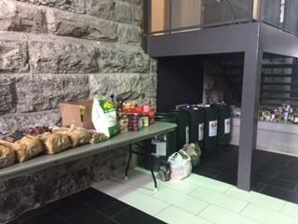
Parent-Teacher Conferences
Wed., Nov. 8th
3:00 pm – 8:00 pm
&
Thurs., Nov 9th
3:00 pm – 8:00 pm
Remember to schedule your appointment online or call Parent Interview toll-free at 1-866-810-0076 anytime before November 7th.

The Thanksgiving Food Drive was a HUGE success!

Catholic parent council
Please consider joining our Catholic School Council. We are always looking for new members and all are welcome to attend! Next meeting will be November 1^{5th} at 5:30 pm in the Learning Commons.
Roots of Empathy
Roots of Empathy has begun in some of our classrooms. The goal of the program is to help students learn how babies grow and that they grow at

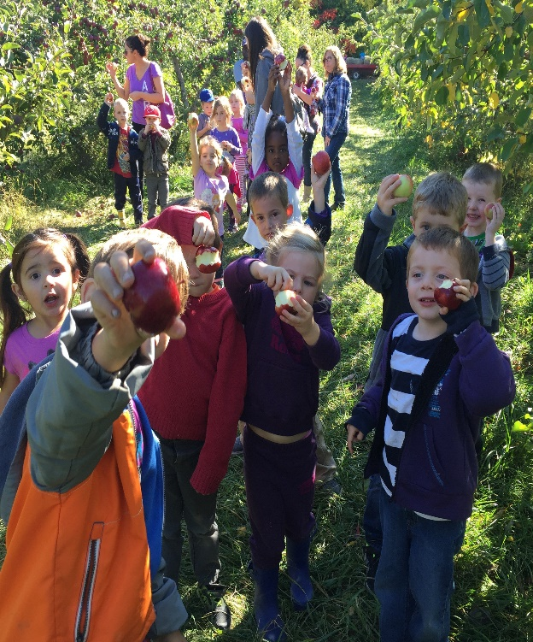

Kindergarten Visits Campbell’s Orchard

Mme. Seamont and Mme. Noack’s French Immersion Kindergarten class visited the orchard and spent some time sampling the crisp apples on a beautiful fall day! Apples were brought back to school for tasty treats!

Algonquin and Lakeshore Catholic Education Foundation is a registered charity that raises funds and provides financial support to assist families within our schools during times of crisis or poverty. This assistance may include the provision of eye glasses, medical supplies, accommodations, food, clothing, or transportation. For more information, go to:
http://www.alcdsb.on.ca/Board/Pages/Foundation.aspx

Breakfast Club volunteers needed 8:00-8:45 am.
Please consider joining a team of volunteers that helps to feed dozens of students each morning. rning per week.

Cereal and Snack Drive
We are hosting a Cereal and Snack Drive the evenings of Parent-Teacher Conferences and throughout the day from November 9th to 13th. We are in need of healthy items to support our daily Breakfast Club and Snack Program. Below is a list of the foods we need:
Rice Krispies Life Cereal Snack-size Applesauce Snack size raisins
Corn Flakes Shreddies Fruit to Go Fruit cups
Cheerio’s Nutri-Grain Bars Soda Crackers Snack size goldfish

French Fun Fact
DID YOU KNOW…
… speaking more than one language can help boost your powers of attention and focus? http://tinyurl.com/zhoh4vc
Encourage your child to be a lifelong learner of French!

Mme. Hartnell is taking Grade 6 French Immersion students and the Grade 5/6 FI Class to the Ontario Science Centre on November 16th. Save the date!!

An Excerpt from ‘Including Students with Special Education Needs in FSL’ Ministry Document
• Students with special education needs benefit from learning French as a second language.
• Specific strategies and supports have been shown to be effective in meeting the needs of students with special education needs.
• Educational policies reflect increasing support for including all students in FSL programs.
An excerpt from the Ministry of Education of Ontario’s website on Progressive Discipline in Schools | What is Progressive Discipline?  Every school in Ontario is required to have a progressive discipline policy.  Through progressive discipline, principals determine appropriate consequences and/ or supports to help students improve their behaviour, while taking into account their individual circumstances. The goal is to help prevent inappropriate student behaviour from happening again.  When schools use progressive discipline, the following should be taken into consideration:  - the students’ stage of growth and development  - the nature and severity of the behaviour  - the impact of the behaviour on the school climate.  Within this context, more serious consequences may be considered for inappropriate behaviour that escalates or is repeated. Providing students with the opportunity to reflect on their own actions and the impact of these actions is essential to student learning.  What Does This Mean in Practice?  Principals will consider a range of options to determine the most appropriate way to respond to each situation and help the student learn from his or her choices. These will include different supports and consequences.  Supports could include:  - a conversation with the student  - a review of expectations for the student’s behaviour  - counselling from a social worker, for example, life skills coaching or anger management.  Consequences could include:  - an assignment  - a detention  - a suspension or an expulsion.  Principals will make these decisions after looking at individual circumstances and mitigating factors like the student’s age, stage of social development, special education needs, history and the circumstances of the behaviour.  Behaviour occurs in a broader context and can be changed over time. Each decision on discipline is unique for each student. It will depend on the strengths and challenges of that student.

